Chapter 11. Adding Internationalization to
Your Shop

In the previous chapter, you added a coupon system to your shop and built a product recommendation engine.

In this chapter, you will learn how internationalization and localization work. By making your application accessible in multiple languages, you can serve a wider range of users. Additionally, by adapting your application to local formatting conventions such as date or number formatting, you improve its usability. By translating and localizing your application, you will make it more intuitive for users from different cultural backgrounds and increase user engagement.
This chapter will cover the following topics:

- Preparing your project for internationalization
- Managing translation files
- Translating Python code
- Translating templates
- Using Rosetta to manage translations
- Translating URL patterns and using a language prefix in URLs
- Allowing users to switch language
- Translating models using django-parler
- Using model translations with the ORM
- Adapting views to use translations
- Using the localized form fields of django-localflavor
Functional overview
Figure 11.1 shows a representation of the views, templates, and functionalities that will be built in this chapter:
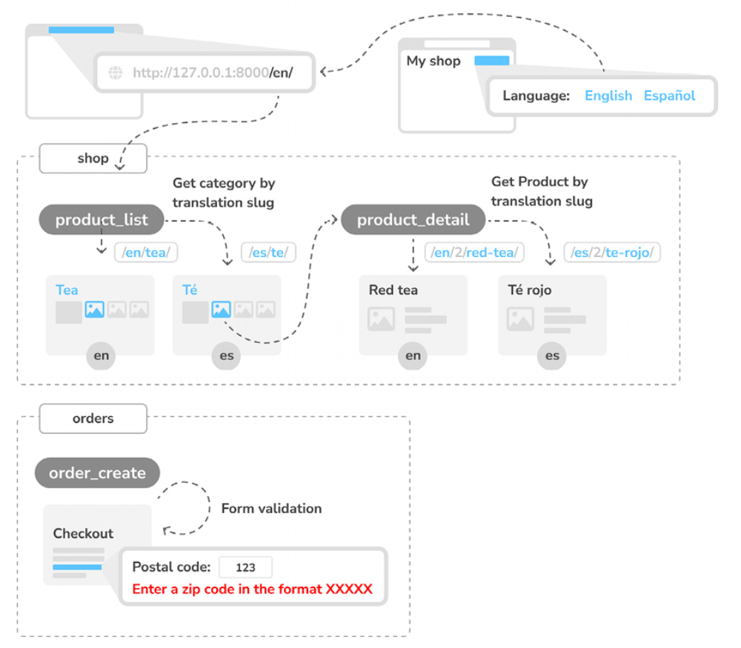
Figure 11.1: Diagram of the functionalities built in Chapter 11

In this chapter, you will implement internationalization in your project and translate templates, URLs, and models. You will add language selection links to the header of your site and create language-specific URLs. You will modify the product_list and product_detail views of the shop application to retrieve Category and Product objects by their translated slugs. You will also add a localized postal code field to the form used in the order_create
view.
The source code for this chapter can be found at
https://github.com/PacktPublishing/Django-5-byexample/tree/main/Chapter11.
All the Python modules used in this chapter are included in the requirements.txt file in the source code that comes with this chapter. You can follow the instructions to install each Python module below, or you can install all the requirements at once with the command python -m pip install -r requirements.txt .

Internationalization with Django
Django offers full internationalization and localization support. It allows you to translate your application into multiple languages, and it handles localespecific formatting for dates, times, numbers, and time zones. Let’s clarify the difference between internationalization and localization:

- Internationalization (frequently abbreviated to i18n) is the process of adapting software for the potential use of different languages and locales so that it isn’t hardwired to a specific language or locale.

- Localization (abbreviated to l10n) is the process of actually translating the software and adapting it to a particular locale. Django itself is translated into more than 50 languages using its internationalization framework.

The internationalization framework allows you to easily mark strings for translation, both in Python code and in your templates. It relies on the GNU gettext toolset to generate and manage message files. A message file is a plain text file that represents a language. It contains a part, or all, of the translation strings found in your application and their respective translations for a single language. Message files have the .po extension. Once the translation is done, message files are compiled to offer rapid access to translated strings. The compiled translation files have the .mo extension.

Let’s review the settings that Django provides for internationalization and
localization.
Internationalization and localization settings
Django provides several settings for internationalization. The following settings are the most relevant ones:

- USE_I18N : A Boolean that specifies whether Django’s translation system is enabled. This is True by default.

- USE_TZ : A Boolean that specifies whether datetimes are time-zoneaware. When you create a project with the startproject command, this is set to True .
- LANGUAGE_CODE : The default language code for the project. This is in the standard language ID format, for example, en-us for American English or en-gb for British English. This setting requires USE_I18N to be set to True in order to take effect. You can find a list of valid language IDs at http://www.i18nguy.com/unicode/language-identifiers.html .

- LANGUAGES : A tuple that contains available languages for the project. They come in two tuples with a language code and a language name. You can see the list of available languages at

- django.conf.global_settings . When you choose which languages your site will be available in, you set LANGUAGES to a subset of that list.

- LOCALE_PATHS : A list of directories where Django looks for message files containing translations for the project.

- TIME_ZONE : A string that represents the time zone for the project. This is set to 'UTC' when you create a new project using the startproject command. You can set it to any other time zone, such as 'Europe/Madrid' .

These are some of the internationalization and localization settings available.
You can find the full list at
https://docs.djangoproject.com/en/5.0/ref/settings/#globalization-i18n-l10n.

After reviewing the most important settings for internationalization and localization, let’s learn how we can create translations for our application.

Internationalization management commands
Django includes the following management commands to manage
translations:

- makemessages : This runs over the source tree to find all the strings marked for translation and creates or updates the .po message files in the locale directory. A single .po file is created for each language.

- compilemessages : This compiles the existing .po message files to .mo files, which are used to retrieve translations.
Django relies on the gettext toolkit to generate and compile translation
files. Let’s review how to install it.

Installing the gettext toolkit
You will need the gettext toolkit to be able to create, update, and compile message files. Most Linux distributions include the gettext toolkit. If you are using macOS, the simplest way to install it is via Homebrew, at https://brew.sh/, with the following command:
brew install gettext

You might also need to force-link it with the following command:
brew link --force gettext

If you are using Windows, follow the steps at
https://docs.djangoproject.com/en/5.0/topics/i18n/translation/#gettext-on-windows. You can download a precompiled gettext binary installer for Windows from
https://mlocati.github.io/articles/gettext-iconvwindows.html.

Once you have installed the gettext toolkit, you are all set to start translating your project. First, you need to understand the steps needed to translate your project and how Django determines the user’s language.

How to add translations to a Django project
Let’s explore the process of internationalizing your project. Here are the steps needed to translate a Django project:

1. Mark the strings for translation in your Python code and your templates.

2. Run the makemessages command to create or update message files that include all the translation strings from your code.

3. Translate the strings contained in the message files.

4. Compile the message files using the compilemessages management command.

We will follow this process to add translations to our project throughout this
chapter.
Next, you are going to learn how Django determines the language of the
current user.
How Django determines the current language
Django comes with a middleware that determines the current language based on the request data. This is the LocaleMiddleware middleware that resides in django.middleware.locale.LocaleMiddleware , which performs the following tasks:

1. If you are using i18n_patterns , that is, you are using translated URL patterns, it looks for a language prefix in the requested URL to determine the current language. You will learn to translate URL patterns in the Translating URL patterns section.

2. If no language prefix is found, it looks for an existing LANGUAGE_SESSION_KEY in the current user’s session.

3. If the language is not set in the session, it looks for an existing cookie with the current language. A custom name for this cookie can be provided in the LANGUAGE_COOKIE_NAME setting. By default, the name for this cookie is django_language .

4. If no cookie is found, it looks for the Accept-Language HTTP header of the request.

5. If the Accept-Language header does not specify a language, Django uses the language defined in the LANGUAGE_CODE setting.

By default, Django will use the language defined in the LANGUAGE_CODE setting unless you are using LocaleMiddleware . The process described here only applies when using this middleware.

We can also let users change their language. You will learn about how to implement a language selector in the section Allowing users to switch language.
Let’s start by configuring our project for internationalization.

Preparing your project for internationalization
We will prepare our project to use different languages. We are going to create an English and a Spanish version for the online shop:

Edit the settings.py file of your project and add the following LANGUAGES setting to it. Place it next to the LANGUAGE_CODE setting:
LANGUAGES = [
('en', 'English'),
('es', 'Spanish'),
]

The LANGUAGES setting contains two tuples that consist of a language code and a name. Language codes can be locale-specific, such as en-us or en-gb , or generic, such as en . With this setting, you specify that your application will only be available in English and Spanish. If you don’t define a custom LANGUAGES setting, the site will be available in all the languages that Django is translated into.

Make your LANGUAGE_CODE setting look like the following:
LANGUAGE_CODE = 'en'

Add 'django.middleware.locale.LocaleMiddleware' to the MIDDLEWARE setting. Make sure that this middleware comes after SessionMiddleware because LocaleMiddleware needs to use session data. It also has to be placed before CommonMiddleware because the latter needs an active language to resolve the requested URL. The MIDDLEWARE setting should now look like the
following:
MIDDLEWARE = [
'django.middleware.security.SecurityMiddleware',
'django.contrib.sessions.middleware.SessionMiddleware',
'django.middleware.locale.LocaleMiddleware',
'django.middleware.common.CommonMiddleware',
'django.middleware.csrf.CsrfViewMiddleware',
'django.contrib.auth.middleware.AuthenticationMiddleware',
'django.contrib.messages.middleware.MessageMiddleware',
'django.middleware.clickjacking.XFrameOptionsMiddleware',
]


The order of middleware classes is very important because each middleware can depend on data set by another middleware that was executed previously. Middleware is
applied for requests in order of appearance in MIDDLEWARE , and in reverse order for responses.

Create the following directory structure inside the main project directory, next to the manage.py file:
locale/
en/
es/

The locale directory is the place where message files for your application will reside.

Edit the settings.py file again and add the following setting to it:
LOCALE_PATHS = [
BASE_DIR / 'locale',
]

The LOCALE_PATHS setting specifies the directories where Django has to look for translation files. Locale paths that appear first have the highest precedence.

When you use the makemessages command from your project directory, message files will be generated in the locale/ path you created. However, for applications that contain a locale/ directory, message files will be generated in that directory.

Your project is now configured for internationalization. Next, you will learn how to translate strings in your Python code.

Translating Python code
We will explore various methods to handle translations within Python code.
We will cover the following methods:

- Standard translations

- Lazy translations: Executed when the value is accessed rather than when the function is called.

- Translations including variables: Used to interpolate variables within strings that are to be translated.

- Plural forms in translations: Techniques to manage translations that depend on numerical quantities that might affect the string being translated.

For translating literals in your Python code, you can mark strings for translation using the gettext() function included in django.utils.translation . This function translates the message and returns a string. The convention is to import this function as a shorter alias named _
(the underscore character).

You can find all the documentation about translations at
https://docs.djangoproject.com/en/5.0/topics/i18n/translation/.
Let’s review the different translation methods for Python strings.

Standard translations
The following code shows how to mark a string for translation:
from django.utils.translation import gettext as _
output = _('Text to be translated.')

This method allows you to apply translations to most strings within your Python code by using the gettext() function, aliased as _ for convenience.

Lazy translations
Django includes lazy versions for all of its translation functions, which have the suffix _lazy() . When using the lazy functions, strings are translated when the value is accessed, rather than when the function is called (this is why they are translated lazily). The lazy translation functions come in handy when the strings marked for translation are in paths that are executed when modules are loaded.

A common example where lazy translations are beneficial is in the settings.py file of your project, where immediate translation is not practical because the settings must be defined before the translation system is fully ready.


Using gettext_lazy() instead of gettext() means that
strings are translated when the value is accessed. Django
offers a lazy version for all translation functions.

Translations including variables
The strings marked for translation can include placeholders to include variables in the translations. The following code is an example of a translation string with a placeholder:
from django.utils.translation import gettext as _
month = _('April')
day = '14'
output = _('Today is %(month)s %(day)s') % {'month': month, 'day

By using placeholders, you can reorder the text variables. For example, an English translation of the previous example might be today is April 14, while the Spanish one might be hoy es 14 de Abril. Always use string interpolation instead of positional interpolation when you have more than one parameter for the translation string. By doing so, you will be able to reorder the placeholder text.

Plural forms in translations
For plural forms, Django provides ngettext() and ngettext_lazy() . These functions translate singular and plural forms, depending on an argument that indicates the number of objects. The following example shows how to use them:
output = ngettext(
'there is %(count)d product', # Singular form
'there are %(count)d products', # Plural form
count # Numeric value to determin
) % {'count': count}

In this example, if count is 1 , ngettext() will use the first string and output there is 1 product . For any other number, it will use the second string, appropriately outputting, for example, there are 5 products . This allows for more accurate and grammatically correct translations in languages where pluralization rules are essential.

Now that you know the basics of translating literals in your Python code, it’s time to apply translations to your project.

Translating your own code
First, we will translate the language names. To do this, you can follow these instructions:

Edit the settings.py file of your project, import the gettext_lazy() function, and change the LANGUAGES setting, as follows:
from django.utils.translation import gettext_lazy as _
# ...
LANGUAGES = [
('en', _('English')),
('es', _('Spanish')),
]

Here, you use the gettext_lazy() function instead of gettext() to avoid a circular import, thus translating the languages’ names when they are accessed.

Open the shell and run the following command from your project directory:
django-admin makemessages --all

You should see the following output:
processing locale es
processing locale en

Take a look at the locale/ directory. You should see a file structure like the following:
en/
LC_MESSAGES/
django.po
es/
LC_MESSAGES/
django.po

A .po message file has been created for each language.

Open es/LC_MESSAGES/django.po with a text editor. At the end of the file, you should be able to see the following:
#: myshop/settings.py:118
msgid "English"
msgstr ""
#: myshop/settings.py:119
msgid "Spanish"
msgstr ""

Each translation string is preceded by a comment showing details about the file and the line where it was found. Each translation includes two strings:

- msgid : The translation string as it appears in the source code.

- msgstr : The language translation, which is empty by default. This iswhere you have to enter the actual translation for the given string.

Fill in the msgstr translations for the given msgid string, as follows:
#: myshop/settings.py:118
msgid "English"
msgstr "Inglés"
#: myshop/settings.py:119
msgid "Spanish"
msgstr "Español"

Save the modified message file, open the shell, and run the following command:
django-admin compilemessages

If everything goes well, you should see an output like the following:
processing file django.po in myshop/locale/en/LC_MESSAGES
processing file django.po in myshop/locale/es/LC_MESSAGES

The output gives you information about the message files that are being
compiled. Take a look at the locale directory of the myshop project again.
You should see the following files:
en/
LC_MESSAGES/
django.mo
django.po
es/
LC_MESSAGES/
django.mo
django.po

You can see that a .mo compiled message file has been generated for each language.

Now that you have translated the language names, let’s translate the model field names that are displayed on the site:

Edit the models.py file of the orders application, and add names marked for translation to the Order model fields, as follows:
from django.utils.translation import gettext_lazy as _
class Order(models.Model):
first_name = models.CharField(_('first name'), max_length=50
last_name = models.CharField(_('last name'), max_length=50)
email = models.EmailField(_('e-mail'))
address = models.CharField(_('address'), max_length=250)
postal_code = models.CharField(_('postal code'), max_length=
city = models.CharField(_('city'), max_length=100)
# ...

You have added names for the fields that are displayed when a user places a new order. These are first_name , last_name , email , address , postal_code , and city . Remember that you can also use the verbose_name attribute to name the fields.

Create the following directory structure inside the orders application
directory:
locale/
en/
es/

By creating a locale directory, the translation strings of this application will be stored in a message file in this directory instead of the main messages file. In this way, you can generate separate translation files for each application.

Open the shell from the project directory and run the following command:
django-admin makemessages --all

You should see the following output:
processing locale es
processing locale en
Open the locale/es/LC_MESSAGES/django.po file of the order application using a text editor. You will see the translation strings for the Order model.
Fill in the following msgstr translations for the given msgid strings:
#: orders/models.py:12
msgid "first name"
msgstr "nombre"
#: orders/models.py:14
msgid "last name"
msgstr "apellidos"
#: orders/models.py:16
msgid "e-mail"
msgstr "e-mail"
#: orders/models.py:17
msgid "address"
msgstr "dirección"
#: orders/models.py:19
msgid "postal code"
msgstr "código postal"
#: orders/models.py:21
msgid "city"
msgstr "ciudad"

After you have finished adding the translations, save the file.

Besides a text editor, you can use Poedit to edit translations. Poedit is a piece of software for editing translations that uses gettext . It is available for Linux, Windows, and macOS. You can download Poedit from https://poedit.net/.

Let’s also translate the forms of your project. The OrderCreateForm of the orders application does not have to be translated. That’s because it is a ModelForm and uses the verbose_name attribute of the Order model fields for the form field labels. You are going to translate the forms of the cart and coupons applications:

Edit the forms.py file inside the cart application directory and add a label attribute to the quantity field of the CartAddProductForm . Then, mark this field for translation, as follows:
from django import forms
from django.utils.translation import gettext_lazy as _
PRODUCT_QUANTITY_CHOICES = [(i, str(i)) for i in range(1, 21)]
class CartAddProductForm(forms.Form):
quantity = forms.TypedChoiceField(
choices=PRODUCT_QUANTITY_CHOICES,
coerce=int,
label=_('Quantity')
)
override = forms.BooleanField(
required=False,
initial=False,
widget=forms.HiddenInput
)

Edit the forms.py file of the coupons application and translate the CouponApplyForm form, as follows:
from django import forms
from django.utils.translation import gettext_lazy as _
class CouponApplyForm(forms.Form):
code = forms.CharField(label=_('Coupon'))

You have added a label to the code field and marked it for translation.

You have finished marking Python strings for translation. Next, you will learn how to mark text for translation in templates.

Translating templates
Django offers the {% translate %} and {% blocktranslate %} template tags
to translate the strings using templates. In order to use the translation
template tags, you have to add {% load i18n %} to the top of your template
to load them.
The {% translate %} template
tag
The {% translate %} template tag allows you to mark a literal for
translation. Internally, Django executes gettext() on the given text. This is
how to mark a string for translation in a template:
{% translate "Text to be translated" %}

You can use as to store the translated content in a variable that you can use throughout your template. The following example stores the translated text in a variable called greeting :
{% translate "Hello!" as greeting %}
<h1>{{ greeting }}</h1>

The {% translate %} tag is useful for simple translation strings, but it can’t handle content for translation that includes variables.

The {% blocktranslate %} template tag
The {% blocktranslate %} template tag allows you to mark content that includes literals and variable content, using placeholders. The following example shows you how to use the {% blocktranslate %} tag, including a name variable in the content for translation:
{% blocktranslate %}Hello {{ name }}!{% endblocktranslate %}

You can use with to include template expressions, such as accessing object attributes or applying template filters to variables. You always have to use placeholders for these. You can’t access expressions or object attributes inside the blocktrans block. The following example shows you how to use with to include an object attribute to which the capfirst filter has been applied:
{% blocktranslate with name=user.name|capfirst %}
Hello {{ name }}!
{% endblocktranslate %}


Use the {% blocktranslate %} tag instead of {% translate %} when you need to include variable content in your translation string.

Now that you are familiar with the translation template tags, let’s put them to use.

Translating the shop templates
Edit the shop/base.html template of the shop application. Make sure that
you load the i18n tag at the top of the template and mark the strings for
translation, as follows. The new code is highlighted in bold:
{% load i18n static %}
<!DOCTYPE html>
<html>
<head>
<meta charset="utf-8" />
<title>
{% block title %}{% translate "My shop" %}{% endblock %}
</title>
<link href="{% static "css/base.css" %}" rel="stylesheet">
</head>
<body>
<div id="header">
<a href="/" class="logo">{% translate "My shop" %}</a>
</div>
<div id="subheader">
<div class="cart">
{% with total_items=cart|length %}
{% if total_items > 0 %}
{% translate "Your cart" %}:
<a href="{% url "cart:cart_detail" %}">
{% blocktranslate with total=cart.get_total_price count items=to
{{ items }} item, ${{ total }}
{% plural %}
{{ items }} items, ${{ total }}
{% endblocktranslate %}
</a>
{% elif not order %}
{% translate "Your cart is empty." %}
{% endif %}
{% endwith %}
</div>
</div>
<div id="content">
{% block content %}
{% endblock %}
</div>
</body>
</html>

Make sure that no template tag is split across multiple lines.

Notice the {% blocktranslate %} tag to display the cart’s summary. The cart’s summary was previously as follows:
{{ total_items }} item{{ total_items|pluralize }},
${{ cart.get_total_price }}

You changed it, and now you use {% blocktranslate with ... %} to set up the placeholder total with the value of cart.get_total_price (the object method called here). You also use count , which allows you to set a variable for counting objects for Django to select the right plural form. You set the items variable to count objects with the value of total_items .

This allows you to set a translation for the singular and plural forms, which you separate with the {% plural %} tag within the {% blocktranslate %} block. The resulting code is:
{% blocktranslate with total=cart.get_total_price count items=to
{{ items }} item, ${{ total }}
{% plural %}
{{ items }} items, ${{ total }}
{% endblocktranslate %}

Next, edit the shop/product/detail.html template of the shop application and add i18n to the {% load %} tag:
{% extends "shop/base.html" %}
{% load i18n static %}
...

Note that {% load %} allows you to load all template tags at once by including the modules separated by spaces. In this case, we load the i18n and static modules that contain template tags.
Then, find the following line:
<input type="submit" value="Add to cart">

Replace it with the following:
<input type="submit" value="{% translate "Add to cart" %}">

Then, find the following line:
<h3>People who bought this also bought</h3>

Replace it with the following:
<h3>{% translate "People who bought this also bought" %}</h3>

Now, translate the orders application template. Edit the orders/order/create.html template of the orders application and mark the text for translation, as follows:
{% extends "shop/base.html" %}
{% load i18n %}
{% block title %}
{% translate "Checkout" %}
{% endblock %}
{% block content %}
<h1>{% translate "Checkout" %}</h1>
<div class="order-info">
<h3>{% translate "Your order" %}</h3>
<ul>
{% for item in cart %}
<li>
{{ item.quantity }}x {{ item.product.name }}
<span>${{ item.total_price }}</span>
</li>
{% endfor %}
{% if cart.coupon %}
<li>
{% blocktranslate with code=cart.coupon.code discount=
"{{ code }}" ({{ discount }}% off)
{% endblocktranslate %}
<span class="neg">- ${{ cart.get_discount|floatformat:
</li>
{% endif %}
</ul>
<p>{% translate "Total" %}: ${{
cart.get_total_price_after_discount|floatformat:2 }}</p>
</div>
<form method="post" class="order-form">
{{ form.as_p }}
<p><input type="submit" value="{% translate "Place order" %}
{% csrf_token %}
</form>
{% endblock %}

Make sure that no template tag is split across multiple lines. Take a look at the following files in the code that accompanies this chapter to see how the strings have been marked for translation:

- The shop application: Template shop/product/list.html

- The orders application: Template orders/order/pdf.html

- The cart application: Template cart/detail.html

- The payments application: Templates payment/process.html , payment/completed.html , and payment/canceled.html


Remember that you can find the source code for this chapter
at
https://github.com/PacktPublishing/Django-5-by-Example/tree/master/Chapter11.

Let’s update the message files to include the new translation strings:
Open the shell and run the following command:
django-admin makemessages --all

The .po files are inside the locale directory of the myshop project, and you’ll see that the orders application now contains all the strings that you marked for translation.

Edit the .po translation files of the project and the orders application, and include Spanish translations in msgstr . You can also use the translated .po files in the source code that accompanies this chapter.

Run the following command to compile the translation files:
django-admin compilemessages

You will see the following output:
processing file django.po in myshop/locale/en/LC_MESSAGES
processing file django.po in myshop/locale/es/LC_MESSAGES
processing file django.po in myshop/orders/locale/en/LC_MESSAGES
processing file django.po in myshop/orders/locale/es/LC_MESSAGES

A .mo file containing compiled translations has been generated for each .po translation file.

Now, you have edited .po files with a text editor or by using Poedit. Next, we are going to use a Django application to edit translations directly within the browser.

Using the Rosetta translation interface
Rosetta is a third-party application that allows you to edit translations directly in the browser, using the same interface as the Django administration site. Rosetta makes it easy to edit .po files, and it updates compiled translation files. This eliminates the need to download and upload translation files, and it supports collaborative editing by multiple users.

Let’s integrate Rosetta into your project:
Install Rosetta via pip using this command:
python -m pip install django-rosetta==0.10.0

Then, add 'rosetta' to the INSTALLED_APPS setting in your project’s settings.py file, as follows:
INSTALLED_APPS = [
# ...
'rosetta',
]

You need to add Rosetta’s URLs to your main URL configuration. Edit the main urls.py file of your project and add the following URL pattern highlighted in bold:
urlpatterns = [
path('admin/', admin.site.urls),
path('cart/', include('cart.urls', namespace='cart')),
path('orders/', include('orders.urls', namespace='orders')),
path('payment/', include('payment.urls', namespace='payment'
path('coupons/', include('coupons.urls', namespace='coupons'
path('rosetta/', include('rosetta.urls')),
path('', include('shop.urls', namespace='shop')),
]

Make sure you place it before the shop.urls pattern to prevent an undesired pattern match.
Open http://127.0.0.1:8000/admin/ and log in as a superuser. Then, navigate to http://127.0.0.1:8000/rosetta/ in your browser. In the Filter menu, click THIRD PARTY to display all the available message files, including those that belong to the orders application.
You should see a list of existing languages, as follows:
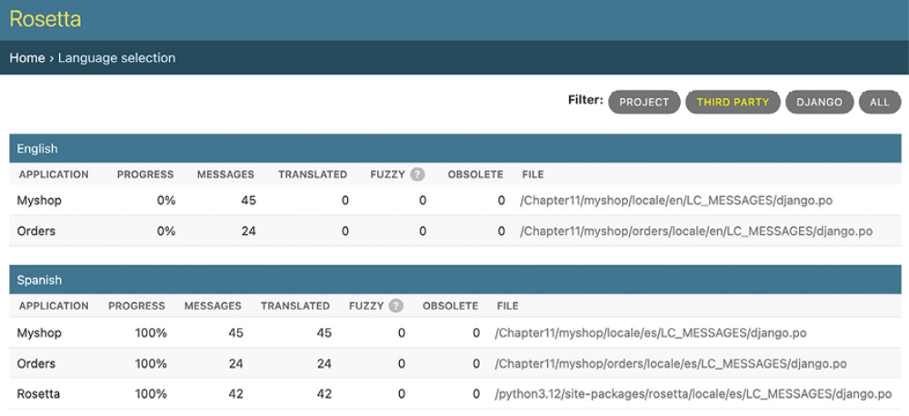
Figure 11.2: The Rosetta administration interface

Click the Myshop link in the Spanish section to edit the Spanish translations. You should see a list of translation strings, as follows:
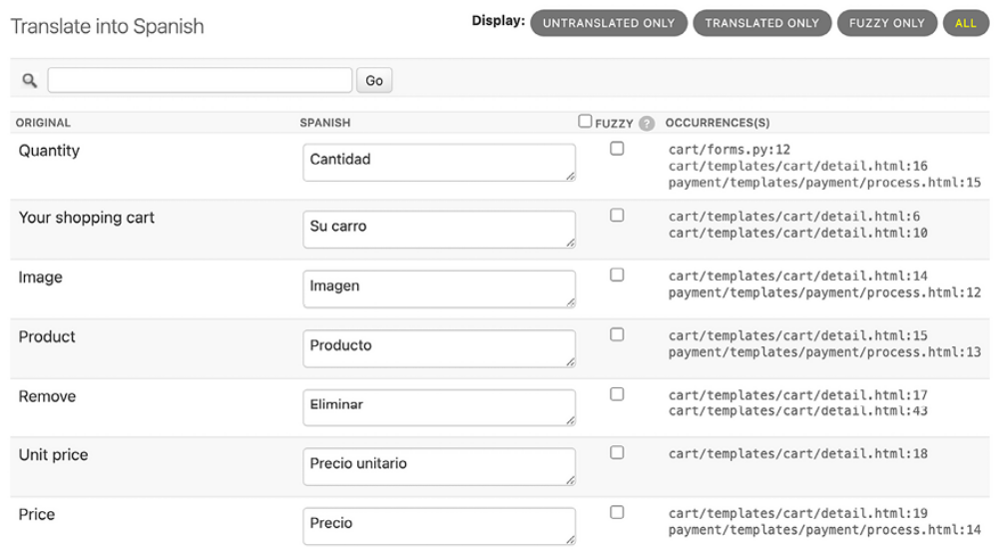
Figure 11.3: Editing Spanish translations using Rosetta

You can enter the translations in the SPANISH column. The OCCURRENCE(S) column displays the files and lines of code where each translation string was found.
Translations that include placeholders will appear as follows:

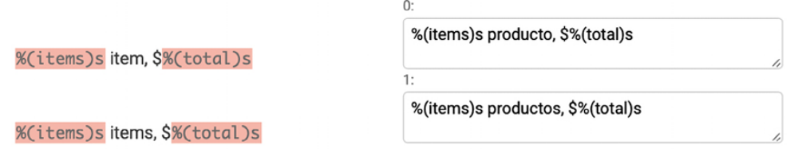
Figure 11.4: Translations including placeholders

Rosetta uses a different background color to display placeholders. When you translate content, make sure that you keep placeholders untranslated. For example, take the following string:
%(items)s items, $%(total)s

It can be translated into Spanish as follows:
%(items)s productos, $%(total)s

You can take a look at the source code that comes with this chapter to use
the same Spanish translations for your project.

When you finish editing translations, click the Save and translate next block button to save the translations to the .po file. Rosetta compiles the message file when you save translations, so there is no need for you to run the compilemessages command. However, Rosetta requires write access to the locale directories to write the message files. Make sure that the directories have valid permissions.

If you want other users to be able to edit translations, open
http://127.0.0.1:8000/admin/auth/group/add/ in your browser and create a new group named translators . Then, access http://127.0.0.1:8000/admin/auth/user/ to edit the users to whom you
want to grant permissions so that they can edit translations. When editing a user, under the Permissions section, add the translators group to the Chosen Groups for each user. Rosetta is only available to superusers or users who belong to the translators group.

You can read Rosetta’s documentation at https://djangorosetta.readthedocs.io/.


When you add new translations to your production
environment, if you serve Django with a real web server, you
will have to reload your server after running the
compilemessages command, or after saving the translations
with Rosetta, for any changes to take effect.

When editing translations, a translation can be marked as fuzzy. Let’s review what fuzzy translations are.

Fuzzy translations
When editing translations in Rosetta, you can see a FUZZY column. This is not a Rosetta feature; it is provided by gettext . If the FUZZY flag is active for a translation, it will not be included in the compiled message files. This flag marks translation strings that need to be reviewed by a translator. When .po files are updated with new translation strings, it is possible that some translation strings will automatically be flagged as fuzzy. This happens when gettext finds some msgid that has been slightly modified. gettext pairs it with what it thinks was the old translation and flags it as fuzzy for review. The translator should then review the fuzzy translations, remove the FUZZY flag, and compile the translation file again.

You have translated your project’s interface, but internationalization doesn’t stop there. You can also translate URL patterns, offering custom URLs tailored for each supported language.

URL patterns for internationalization
Django offers internationalization capabilities for URLs. It includes two main features for internationalized URLs:

- A language prefix in URL patterns: Adding a language prefix to URLs to serve each language version under a different base URL

- Translated URL patterns: Translating URL patterns so that every URL is different for each language

One reason for translating URLs is to optimize your site for search engines. By adding a language prefix to your patterns, you will be able to index a URL for each language instead of a single URL for all of them. Furthermore, by translating URLs into each language, you will provide search engines with URLs that will rank better for each language.

Adding a language prefix to URL patterns
Django allows you to add a language prefix to your URL patterns. For example, the English version of your site can be served by a path starting with /en/ , and the Spanish version under /es/ . To use languages in URL patterns, you have to use the LocaleMiddleware provided by Django. The framework will use it to identify the current language from the requested URL. Previously, you added it to the MIDDLEWARE setting of your project, so
you don’t need to do it now.

Let’s add a language prefix to your URL patterns:
Edit the main urls.py file of the myshop project and add i18n_patterns() , as follows:
from django.conf.urls.i18n import i18n_patterns
urlpatterns = i18n_patterns(
path('admin/', admin.site.urls),
path('cart/', include('cart.urls', namespace='cart')),
path('orders/', include('orders.urls', namespace='orders')),
path('payment/', include('payment.urls', namespace='payment'
path('coupons/', include('coupons.urls', namespace='coupons'
path('rosetta/', include('rosetta.urls')),
path('', include('shop.urls', namespace='shop')),
)

You can combine non-translatable standard URL patterns and patterns under i18n_patterns so that some patterns include a language prefix and others don’t. However, it’s better to use translated URLs only to avoid the possibility that a carelessly translated URL matches a non-translated URL pattern.

Run the development server and open http://127.0.0.1:8000/ in your browser. Django will perform the steps described in the How Django determines the current language section to determine the current language, and it will redirect you to the requested URL, including the language prefix. Take a look at the URL in your browser; it should now look like http://127.0.0.1:8000/en/ . The current language is the one set by the Accept-Language header of your browser if it is Spanish or English; otherwise, it is the default LANGUAGE_CODE (English) defined in your settings.

You have added a language prefix to your URLs, generating a different URL for each language available. This helps you to index different versions in search engines.

Next, we are going to translate URL patterns so that we can add fully translated URLs to our site.

Translating URL patterns
Django supports translated strings in URL patterns. You can use a different translation for each language for a single URL pattern. You can mark URL patterns for translation in the same way you would with literals, using the gettext_lazy() function. To do this, follow these steps:

Edit the main urls.py file of the myshop project and add translation strings to the regular expressions of the URL patterns for the cart , orders , payment , and coupons applications, as follows:
from django.utils.translation import gettext_lazy as _
urlpatterns = i18n_patterns(
path('admin/', admin.site.urls),
path(_('cart/'), include('cart.urls', namespace='cart')),
path(_('orders/'), include('orders.urls', namespace='orders'
path(_('payment/'), include('payment.urls', namespace='payme
path(_('coupons/'), include('coupons.urls', namespace='coupo
path('rosetta/', include('rosetta.urls')),
path('', include('shop.urls', namespace='shop')),
)

Edit the urls.py file of the orders application and mark the order_create URL pattern for translation, as follows:
from django.utils.translation import gettext_lazy as _
urlpatterns = [
path(_('create/'), views.order_create, name='order_create'),
# ...
]

Edit the urls.py file of the payment application and change the code to the following:
from django.utils.translation import gettext_lazy as _
urlpatterns = [
path(_('process/'), views.payment_process, name='process'),
path(_('completed/'), views.payment_completed, name='complet
path(_('canceled/'), views.payment_canceled, name='canceled'
path('webhook/', webhooks.stripe_webhook, name='stripe-webho
]

Note that these URL patterns will include a language prefix because they are included under i18n_patterns() in the main urls.py file of the project. This will make each URL pattern have a different URI for each available language, one starting with /en/ , another one with /es/ , and so on.

However, we need a single URL for Stripe to notify events, and we need to avoid language prefixes in the webhook URL. Remove the webhook URL pattern from the urls.py file of the payment application. The file should now look like the following:
from django.utils.translation import gettext_lazy as _
urlpatterns = [
path(_('process/'), views.payment_process, name='process'),
path(_('completed/'), views.payment_completed, name='complet
path(_('canceled/'), views.payment_canceled, name='canceled'
]

Then, add the following webhook URL pattern to the main urls.py file of the myshop project. The new code is highlighted in bold:
from django.utils.translation import gettext_lazy as _
from payment import webhooks
urlpatterns = i18n_patterns(
path('admin/', admin.site.urls),
path(_('cart/'), include('cart.urls', namespace='cart')),
path(_('orders/'), include('orders.urls', namespace='orders'
path(_('payment/'), include('payment.urls', namespace='payme
path(_('coupons/'), include('coupons.urls', namespace='coupo
path('rosetta/', include('rosetta.urls')),
path('', include('shop.urls', namespace='shop')),
)
urlpatterns += [
path(
'payment/webhook/',
webhooks.stripe_webhook,
name='stripe-webhook'
),
]
if settings.DEBUG:
urlpatterns += static(
settings.MEDIA_URL, document_root=settings.MEDIA_ROOT
)

We have added the webhook URL pattern to urlpatterns outside of i18n_patterns() to ensure we maintain a single URL for Stripe event notifications.

You don’t need to translate the URL patterns of the shop application, as they are built with variables and do not include any other literals.

Open the shell and run the next command to update the message files with
the new translations:
django-admin makemessages --all

Make sure the development server is running with the following command:
python manage.py runserver
Open http://127.0.0.1:8000/en/rosetta/ in your browser and click the Myshop link under the Spanish section. Click on UNTRANSLATED ONLY to only see the strings that have not been translated yet. Now, you will see the URL patterns for translation, as shown in Figure 11.5:
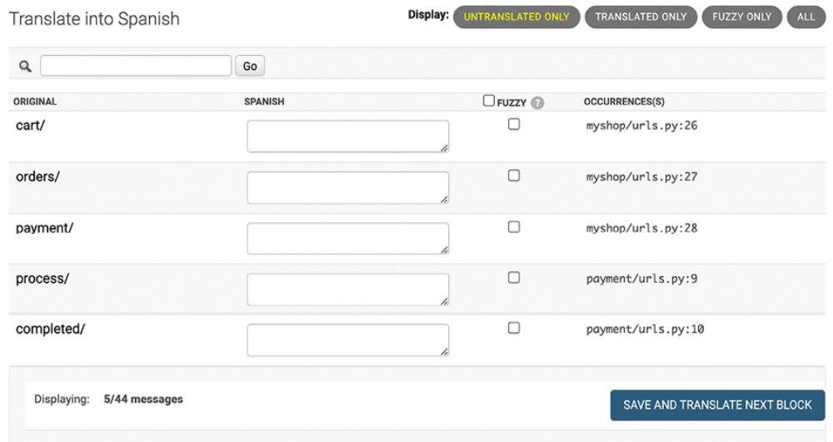
Figure 11.5: URL patterns for translation in the Rosetta interface

Add a different translation string for each URL. Don’t forget to include a slash character, / , at the end of each URL, as shown in Figure 11.6:
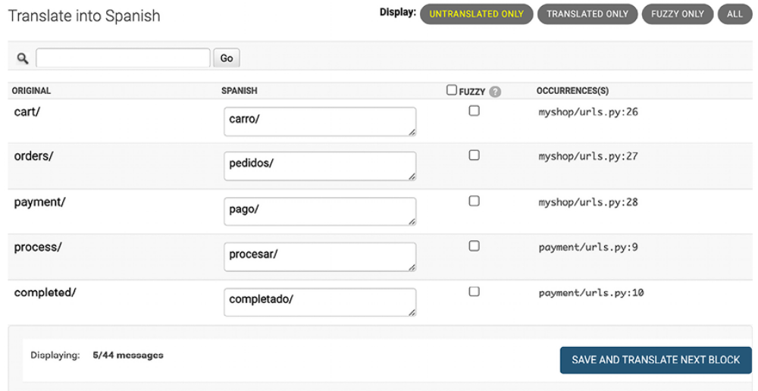
Figure 11.6: Spanish translations for URL patterns in the Rosetta interface
When you have finished, click SAVE AND TRANSLATE NEXT BLOCK.

Then, click on FUZZY ONLY. You will see translations that have been flagged as fuzzy because they were paired with the old translation of a similar original string. In the case displayed in Figure 11.7, the translations are incorrect and need to be corrected:
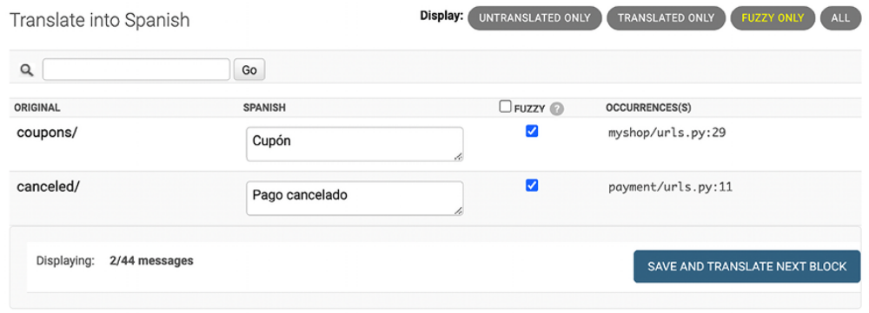
Figure 11.7: Fuzzy translations in the Rosetta interface

Enter the correct text for the fuzzy translations. Rosetta will automatically uncheck the FUZZY select box when you enter new text for a translation. When you have finished, click SAVE AND TRANSLATE NEXT BLOCK:
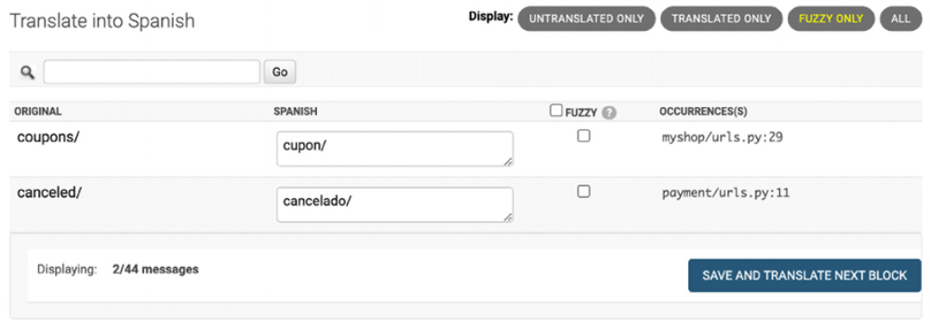
Figure 11.8: Correcting fuzzy translations in the Rosetta interface

You can now go back to http://127.0.0.1:8000/en/rosetta/files/thirdparty/ and edit the Spanish translation for the orders application as well.

After translating the strings into Spanish, our site will be available in two languages. You have already learned how Django determines the current language. However, users may wish to switch languages. Let’s create the functionality that allows users to change their language preference.
Allowing users to switch language
Since you are serving content that is available in multiple languages, you should let your users switch the site’s language. You are going to add a language selector to your site. The language selector will consist of a list of available languages displayed using links.

Edit the shop/base.html template of the shop application and locate the
following lines:
<div id="header">
<a href="/" class="logo">{% translate "My shop" %}</a>
</div>

Replace them with the following code:
<div id="header">
<a href="/" class="logo">{% translate "My shop" %}</a>
{% get_current_language as LANGUAGE_CODE %}
{% get_available_languages as LANGUAGES %}
{% get_language_info_list for LANGUAGES as languages %}
<div class="languages">
<p>{% translate "Language" %}:</p>
<ul class="languages">
{% for language in languages %}
<li>
<a href="/{{ language.code }}/"
{% if language.code == LANGUAGE_CODE %} class="selecte
{{ language.name_local }}
</a>
</li>
{% endfor %}
</ul>
</div>
</div>

Make sure that no template tag is split into multiple lines.
This is how you build your language selector:

- You load the internationalization tags using {% load i18n %} .

- You use the {% get_current_language %} tag to retrieve the current language.

- You get the languages defined in the LANGUAGES setting using the {% get_available_languages %} template tag.

- You use the tag {% get_language_info_list %} to provide easy access to the language attributes.
- You build an HTML list to display all available languages, and you add a selected class attribute to the currently active language.

In the code for the language selector, you used the template tags provided by i18n , based on the languages available in the settings of your project. Now, open http://127.0.0.1:8000/ in your browser and take a look. You should see the language selector in the top right-hand corner of the site, as follows:
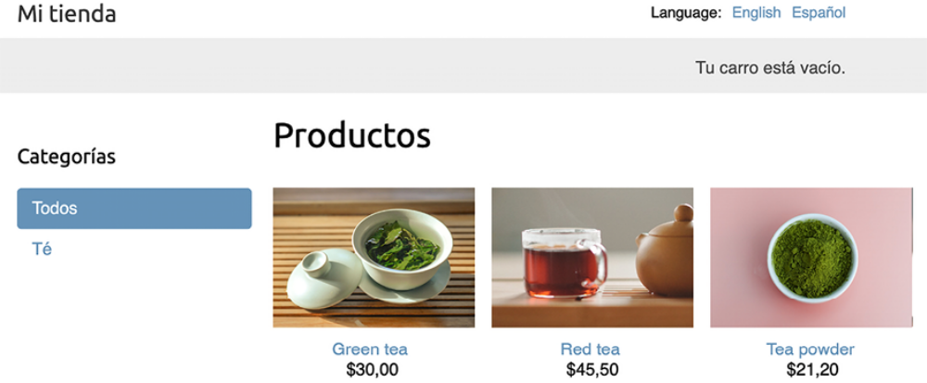
Figure 11.9: The product list page, including a language selector in the site header


Images in this chapter:

Green tea: Photo by Jia Ye on Unsplash
Red tea: Photo by Manki Kim on Unsplash
Tea powder: Photo by Phuong Nguyen on Unsplash

Users can now effortlessly switch to their preferred language by selecting from the options available in the language selector.

Translating models with django-parler
Django does not include built-in support to translate models. To manage content in multiple languages, you can either develop a custom solution or opt for a third-party module that facilitates model translation. There are several third-party applications available, each employing a unique method for storing and retrieving translations. One of these applications is djangoparler . This module provides a very effective approach for translating models and integrates smoothly with Django’s administration site.

django-parler generates a separate database table for each model that contains translations. This table includes all the translated fields and a foreign key for the original object that the translation belongs to. It also contains a language field, since each row stores the content for a single language.


The django-parler package has not received updates for
several years. Despite this, many developers continue to use
it because of its proven effectiveness in facilitating model
translations.

Installing django-parler
Install django-parler via pip using the following command:
python -m pip install django-parler==2.3

Edit the settings.py file of your project and add 'parler' to the INSTALLED_APPS setting, as follows:
INSTALLED_APPS = [
# ...
'parler',
]

Also, add the following code to your settings:
# django-parler settings
PARLER_LANGUAGES = {
None: (
{'code': 'en'},
{'code': 'es'},
),
'default': {
'fallback': 'en',
'hide_untranslated': False,
}
}

This setting defines the available languages, en and es , for django-parler . You specify the default language, en , and indicate that django-parler should not hide untranslated content.

Parler is now activated in our project. Let’s add translation capabilities to our model fields.
Translating model fields
Let’s add translations to your product catalog. django-parler provides a TranslatableModel model class and a TranslatedFields wrapper to translate model fields. You can follow these instructions:
Edit the models.py file inside the shop application directory and add the
following import:
from parler.models import TranslatableModel, TranslatedFields

Then, modify the Category model to make the name and slug fields translatable, as follows:
class Category(TranslatableModel):
translations = TranslatedFields(
name = models.CharField(max_length=200),
slug = models.SlugField(max_length=200, unique=True),
)

The Category model now inherits from TranslatableModel instead of models.Model , and both the name and slug fields are included in the TranslatedFields wrapper.
Edit the Product model to add translations for the name , slug , and
description fields, as follows:
class Product(TranslatableModel):
translations = TranslatedFields(
name = models.CharField(max_length=200),
slug = models.SlugField(max_length=200),
description = models.TextField(blank=True)
)
category = models.ForeignKey(
Category,
related_name='products',
on_delete=models.CASCADE
)
image = models.ImageField(
upload_to='products/%Y/%m/%d',
blank=True
)
price = models.DecimalField(max_digits=10, decimal_places=2)
available = models.BooleanField(default=True)
created = models.DateTimeField(auto_now_add=True)
updated = models.DateTimeField(auto_now=True)

django-parler manages translations by generating another model for each translatable model. In the following schema, you can see the fields of the Product model and what the generated ProductTranslation model will look like:
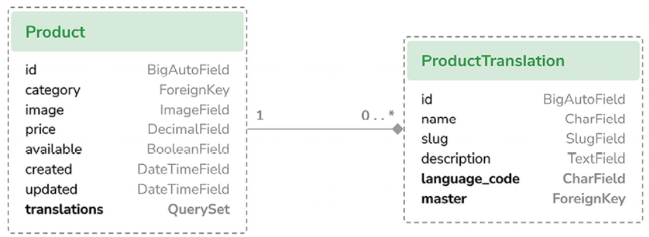
Figure 11.10: The Product model and related ProductTranslation model generated by django-parler

The ProductTranslation model generated by django-parler includes the name , slug , and description translatable fields, a language_code field, and a ForeignKey for the master Product object. There is a one-to-many relationship from Product to ProductTranslation . A ProductTranslation object will exist for each available language of each Product object.

Since Django uses a separate table for translations, there are some Django features that you can’t use. It is not possible to use a default order with a translated field. You can filter by translated fields in queries, but you can’t include a translatable field in the ordering Meta options. Also, you can’t use indexes for the fields that are translated, as these fields will not exist in the original model because they will reside in the translation model.
Edit the models.py file of the shop application and comment out the
ordering and indexes attributes of the Category Meta class:
class Category(TranslatableModel):
# ...
class Meta:
# ordering = ['name']
# indexes = [
# models.Index(fields=['name']),
# ]
verbose_name = 'category'
verbose_name_plural = 'categories'

You also have to comment out the ordering and attribute of the Product Meta class and the indexes that refer to the translated fields. Comment out the following lines of the Product Meta class:
class Product(TranslatableModel):
# ...
class Meta:
# ordering = ['name']
indexes = [
# models.Index(fields=['id', 'slug']),
# models.Index(fields=['name']),
models.Index(fields=['-created']),
]

You can read more about the django-parler module’s compatibility with
Django at https://django-parler.readthedocs.io/en/latest/compatibility.html.
Let’s continue by integrating the translatable models into the administration site.

Integrating translations into the administration site
django-parler integrates seamlessly with the Django administration site. This allows you to easily edit different translations of your objects through the user-friendly admin interface. It includes a TranslatableAdmin class that overrides the ModelAdmin class provided by Django to manage model translations.

Edit the admin.py file of the shop application and add the following import to it:
from parler.admin import TranslatableAdmin

Modify the CategoryAdmin and ProductAdmin classes to inherit from TranslatableAdmin instead of ModelAdmin . The django-parler module doesn’t support the prepopulated_fields attribute, but it does support the get_prepopulated_fields() method that provides the same functionality.

Let’s change this accordingly. Edit the admin.py file to make it look like the following:
from django.contrib import admin
from parler.admin import TranslatableAdmin
from .models import Category, Product
@admin.register(Category)
class CategoryAdmin(TranslatableAdmin):
list_display = ['name', 'slug']
def get_prepopulated_fields(self, request, obj=None):
return {'slug': ('name',)}
@admin.register(Product)
class ProductAdmin(TranslatableAdmin):
list_display = [
'name',
'slug',
'price',
'available',
'created',
'updated'
]
list_filter = ['available', 'created', 'updated']
list_editable = ['price', 'available']
def get_prepopulated_fields(self, request, obj=None):
return {'slug': ('name',)}
You have adapted the administration site to work with the new translated models. You can now sync the database with the model changes that you made.

Creating migrations for model translations
To create migrations, follow these instructions:

Open the shell and run the following command to create a new migration for the model translations:
python manage.py makemigrations shop --name "translations"

You will see the following output:
Migrations for 'shop':
shop/migrations/0002_translations.py
- Create model CategoryTranslation
- Create model ProductTranslation
- Change Meta options on category
- Change Meta options on product
- Remove index shop_catego_name_289c7e_idx from category
- Remove index shop_produc_id_f21274_idx from product
- Remove index shop_produc_name_a2070e_idx from product
- Remove field name from category
- Remove field slug from category
- Remove field description from product
- Remove field name from product
- Remove field slug from product
- Add field master to producttranslation
- Add field master to categorytranslation
- Alter unique_together for producttranslation (1 constraint(
- Alter unique_together for categorytranslation (1 constraint

This migration automatically includes the CategoryTranslation and ProductTranslation models created dynamically by django-parler . It’s important to note that this migration deletes the previous existing fields from your models.

This means that you will lose that data and need to set your categories and products again on the administration site after running it.

Edit the file migrations/0002_translations.py of the shop application and
identify the two occurrences of the following line:
bases=(parler.models.TranslatedFieldsModelMixin, models.Model),

Replace those occurrences with the following:
bases=(parler.models.TranslatableModel, models.Model),

This is a fix for a minor issue found in the django-parler version you are using. This change is necessary to prevent the migration from failing when applying it. This issue is related to creating translations for existing fields in the model and shall be fixed in newer django-parler versions.

Run the following command to apply the migration:
python manage.py migrate shop

You will see an output that ends with the following line:
Applying shop.0002_ categorytranslation_producttranslation_and_mo

Your models are now synchronized with the database.
Run the development server using the following command:
python manage.py runserver

Open http://127.0.0.1:8000/en/admin/shop/category/ in your browser. You will see that existing categories lost their name and slug, due to deleting those fields and using the translatable models generated by django-parler instead. You will just see a dash under each column, like in Figure 11.11:
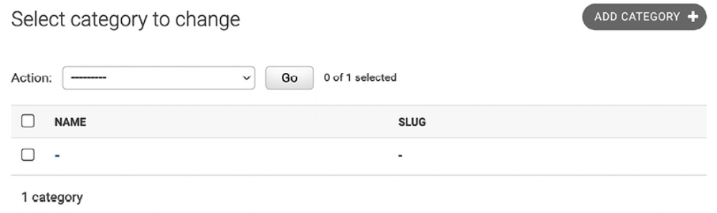
Figure 11.11: The category list on the Django administration site after creating the translation models

Click on the dash under the category name to edit it. You will see that the Change category page includes two different tabs, one for English and one for Spanish translations:
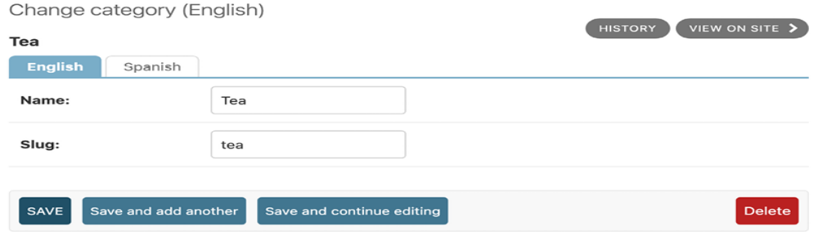
Figure 11.12: The category edit form, including the language tabs added by django-parler
Make sure that you fill in a name and slug for all existing categories. When you edit a category, enter the English details and click on Save and continue editing. Then, click on Spanish, add the Spanish translation for the fields, and click on SAVE:
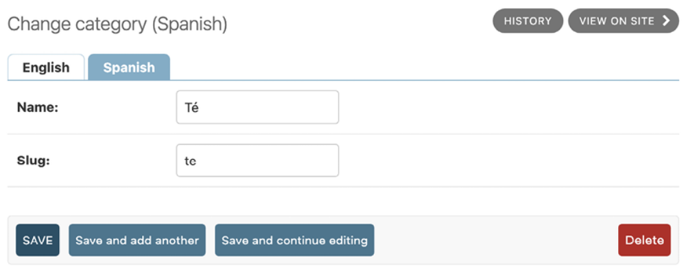
Figure 11.13: The Spanish translation of the category edit form

Make sure to save the changes before switching between the language tabs.

After you complete the data for existing categories, open http://127.0.0.1:8000/en/admin/shop/product/ and edit each of the products, providing an English and Spanish name, a slug, and a description.

Once the translations are in place, the next step will be to explore how to interact with the translated fields through the Django ORM.

Using translations in QuerySets
Let’s take a look at how to work with translations in QuerySets. Run the
following command to open the Python shell:
python manage.py shell

Let’s take a look at how you can retrieve and query translation fields. To get the object with translatable fields translated into a specific language, you can use Django’s activate() function, as follows:
>>> from shop.models import Product
>>> from django.utils.translation import activate
>>> activate('es')
>>> product=Product.objects.first()
>>> product.name
'Té verde'

Another way to do this is by using the language() manager provided by django-parler , as follows:
>>> product=Product.objects.language('en').first()
>>> product.name
'Green tea'

When you access translated fields, they are resolved using the current language. You can set a different current language for an object to access that specific translation, as follows:
>>> product.set_current_language('es')
>>> product.name
'Té verde'
>>> product.get_current_language()
'es'

When performing a QuerySet using filter() , you can filter using the related translation objects with the translations__ syntax, as follows:
>>> Product.objects.filter(translations__name='Green tea')
<TranslatableQuerySet [<Product: Té verde>]>

Let’s apply what we have learned to our views.

Adapting views for translations
Let’s adapt the product catalog views:

Edit the views.py file of the shop application and add the following code
highlighted in bold to the product_list view:
def product_list(request, category_slug=None):
category = None
categories = Category.objects.all()
products = Product.objects.filter(available=True)
if category_slug:
language = request.LANGUAGE_CODE
category = get_object_or_404(
Category,
translations__language_code=language,
translations__slug=category_slug
)
products = products.filter(category=category)
return render(
request,
'shop/product/list.html',
{
' category': category,
'categories': categories,
'products': products
}
)

Then, edit the product_detail view and add the following code highlighted in bold:
def product_detail(request, id, slug):
language = request.LANGUAGE_CODE
product = get_object_or_404(
Product,
id=id,
translations__language_code=language,
translations__slug=slug,
available=True
)
cart_product_form = CartAddProductForm()
r = Recommender()
recommended_products = r.suggest_products_for([product], 4)
return render(
request,
'shop/product/detail.html',
{
'product': product,
'cart_product_form': cart_product_form,
'recommended_products': recommended_products
}
)

The product_list and product_detail views are now adapted to retrieve objects using translated fields.
Run the development server with the following command:
python manage.py runserver

Open http://127.0.0.1:8000/es/ in your browser. You should see the product list page, including all products translated into Spanish:
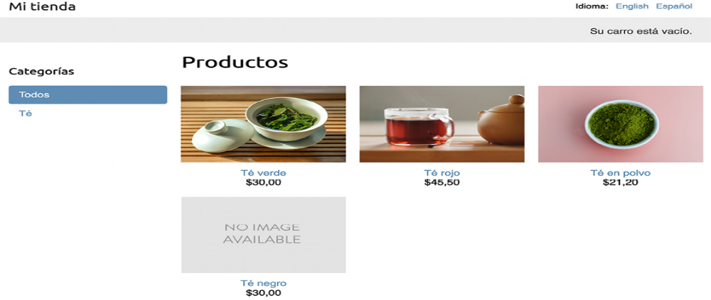
Figure 11.14: The Spanish version of the product list page
Now, each product’s URL is built using the slug field translated into the current language. For example, the URL for a product in Spanish is http://127.0.0.1:8000/es/2/te-rojo/ , whereas, in English, the URL is http://127.0.0.1:8000/en/2/red-tea/ . If you navigate to a product details page, you will see the translated URL and the contents of the selected language, as shown in the following example:
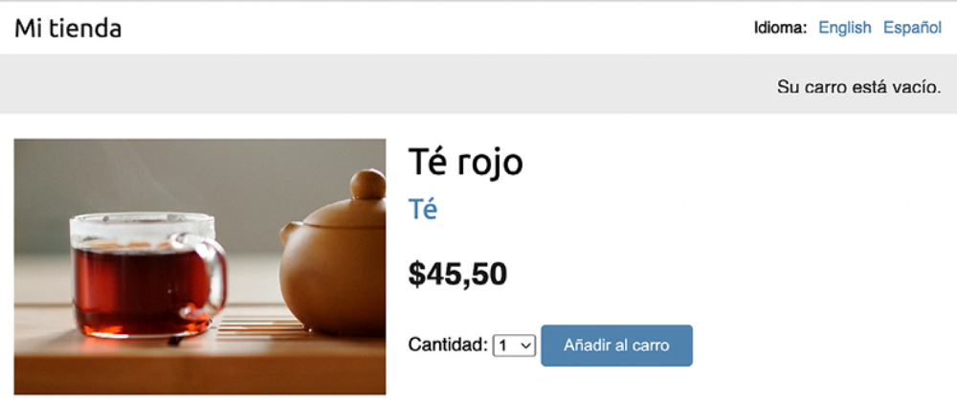
Figure 11.15: The Spanish version of the product details page

If you want to know more about django-parler , you can find the full documentation at https://django-parler.readthedocs.io/en/latest/.

You have learned how to translate Python code, templates, URL patterns, and model fields. To complete the internationalization and localization process, you need to use localized formatting for dates, times, and numbers as well.

Format localization
To enhance user experience, it’s important to present dates, times, and numbers in formats that align with the user’s locale. Adapting your site to the data formats familiar to users in various regions significantly improves its accessibility. Since Django 5.0, localized formatting of data is always enabled. Django displays numbers and dates using the format of the current locale.

Django tries to use a locale-specific format whenever it outputs a value in a template. Figure 11.16 shows the format localization for decimal numbers in the English and Spanish versions of the site:
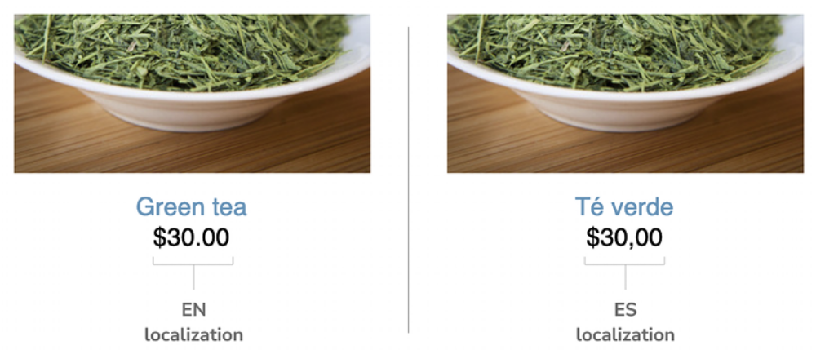
Figure 11.16: Format localization in English and Spanish

Decimal numbers in the English version are displayed with a dot separator for decimal places, while in the Spanish version, a comma is used as the separator. This is due to the locale formats specified for the en and es locales by Django. You can take a look at the English formatting configuration at
https://github.com/django/django/blob/stable/5.0.x/django/conf/locale/en/formats.py and the Spanish formatting configuration at
https://github.com/django/django/blob/stable/5.0.x/django/conf/locale/es/formats.py.

By default, Django applies the format localization for each locale. However, there might be cases for which you don’t want to use localized values. This is especially relevant when outputting JavaScript or JSON, which has to provide a machine-readable format.

Django offers a {% localize %} template tag that allows you to turn on/off localization for template fragments. This gives you control over localized formatting. You will have to load the l10n (localization) tags to be able to use this template tag. The following is an example of how to turn localization on and off in a template:
{% load l10n %}
{% localize on %}
{{ value }}
{% endlocalize %}
{% localize off %}
{{ value }}
{% endlocalize %}

Django also offers the localize and unlocalize template filters to force or avoid the localization of a value. These filters can be applied as follows:
{{ value|localize }}
{{ value|unlocalize }}
You can also create custom format files to specify locale formatting. You can find further information about format localization at
https://docs.djangoproject.com/en/5.0/topics/i18n/formatting/.

Next, you will learn how to create localized form fields.

Using django-localflavor to validate form fields
django-localflavor is a third-party module that contains a collection of utilities, such as form fields or model fields, that are specific for each country. It’s very useful for validating local regions, local phone numbers, identity card numbers, social security numbers, and so on. The package is organized into a series of modules named after ISO 3166 country codes.
Follow these instructions to set it up:
Install django-localflavor using the following command:
python -m pip install django-localflavor==4.0

Edit the settings.py file of your project and add localflavor to the
INSTALLED_APPS setting, as follows:
INSTALLED_APPS = [
# ...
'localflavor',
]

You are going to add the United States zip code field so that a valid United States zip code is required to create a new order. Edit the forms.py file of the orders application and make it look like the following:
from django import forms
from localflavor.us.forms import USZipCodeField
from .models import Order
class OrderCreateForm(forms.ModelForm):
postal_code = USZipCodeField()
class Meta:
model = Order
fields = [
'first_name',
'last_name',
'email',
'address',
'postal_code',
'city'
]

You import the USZipCodeField field from the us package of localflavor and use it for the postal_code field of the OrderCreateForm form.
Run the development server with the following command:
python manage.py runserver

Open http://127.0.0.1:8000/en/orders/create/ in your browser. Fill in all the fields, enter a three-letter zip code, and then submit the form. You will get the following validation error, which is raised by USZipCodeField :
Enter a zip code in the format XXXXX or XXXXX-XXXX.

Figure 11.17 shows the form validation error:
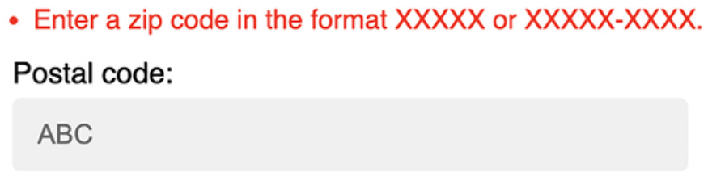
Figure 11.17: The validation error for an invalid US zip code

This is just a brief example of how to use a custom field from localflavor in your own project for validation purposes. The local components provided by localflavor are very useful for adapting your application to specific countries. You can read the django-localflavor documentation and see all the available local components for each country at https://djangolocalflavor.readthedocs.io/en/latest/.
Expanding your project using AI
In this section, you are presented with a task to extend your project, accompanied by a sample prompt for ChatGPT to assist you. To engage with ChatGPT, visit https://chat.openai.com/. If this is your first interaction with ChatGPT, you can revisit the Expanding your project using AI section in Chapter 3, Extending Your Blog Application.

In this project example, we have implemented an online shop. We have added orders, payments, and a coupon system. Now, another typical feature of e-commerce platforms is managing shipping costs. Let’s consider adding a weight attribute to products and implementing shipping costs based on the total weight of the items shipped. Use ChatGPT to help you implement shipping costs for products, making them dependent on the product’s weight. Ensure that Stripe charges the correct amount, including the calculated shipping costs. You can use the prompt provided at
https://github.com/PacktPublishing/Django-5-byexample/ blob/main/Chapter11/prompts/task.md.

Use ChatGPT as a debugging companion. If you find
yourself stuck on a particularly stubborn bug, describe the
problem and the context. It can provide a fresh perspective,
often prompting you to consider angles you might have
overlooked, leading to quicker problem resolution.

Summary
In this chapter, you learned the basics of the internationalization and localization of Django projects. You marked code and template strings for translation, and you discovered how to generate and compile translation files. You also installed Rosetta in your project to manage translations through a web interface. You translated URL patterns, and you created a language selector to allow users to switch the language of the site. Then, you used django-parler to translate models, and you used django-localflavor
to validate localized form fields.

In the next chapter, you will start a new Django project that will consist of an e-learning platform. You will learn how to use model inheritance to implement polymorphism, and you will lay the foundations for a flexible content management system. You will create the application models, and you will learn how to create and apply fixtures to provide initial data for the models. You will build a custom model field and use it in your models. You will also build authentication views for your new application.

Additional resources
The following resources provide additional information related to the topics
covered in this chapter:
The source code for this chapter: ( See page 809 )

